**Lab Exercise - 3**

**Q1: Write a program in C# to store elements in an array and print it.**

**Solution:**

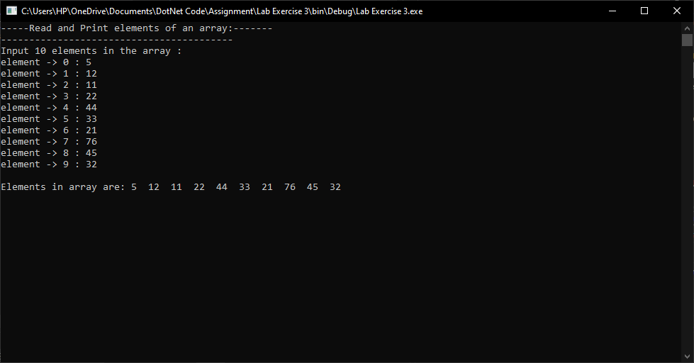

**Q2: Write a program in C# to read n number of values in an array and display it in reverse order**

**Solution:**

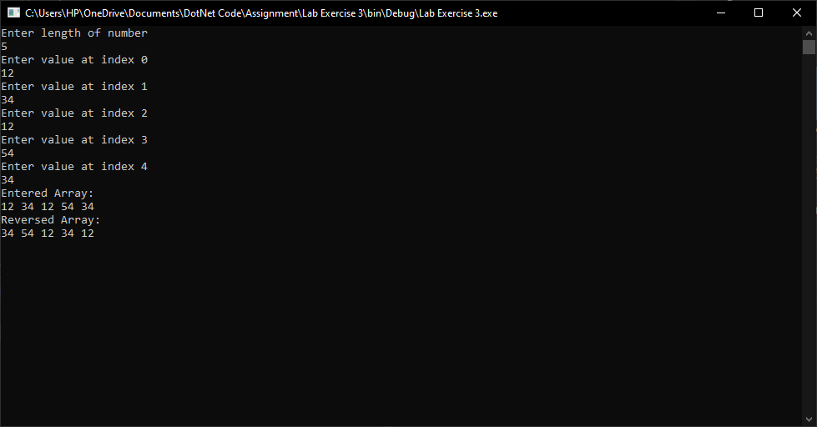

**Q 3: Write a program in C# to find the sum of all elements of array.**

**Solution:**

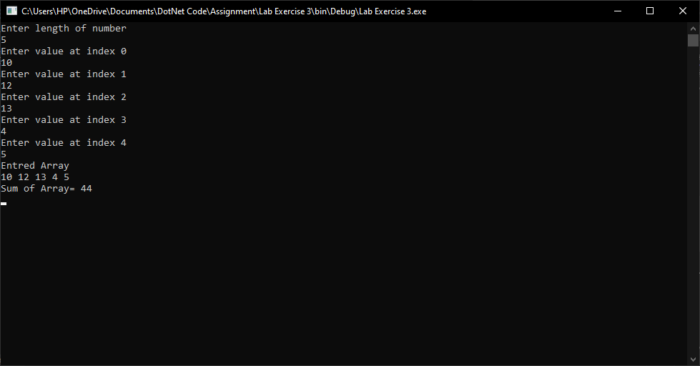

**Q 4: Write a program in C# to copy the elements one array into another array.**

**Solution:**

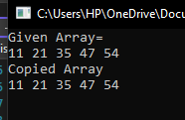

**Q5: Write a program in C# to create Dynamic 2D array of size 3x3, store elements in an array and print it.**

**Solution:**

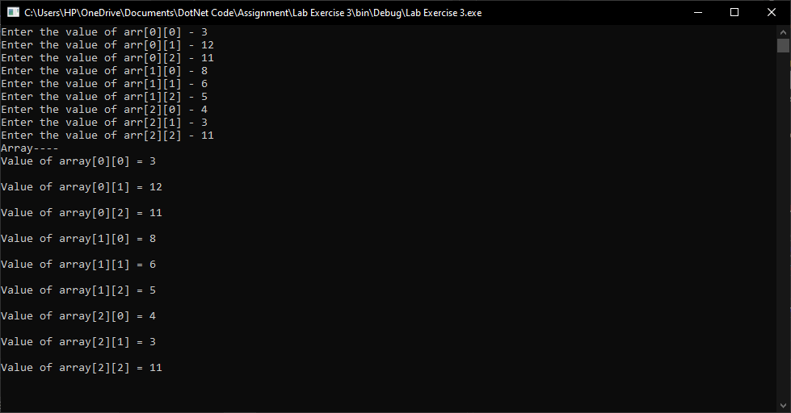

**Q6: Write a program in C# to create 3D array with elements in an array and print it.**

**Solution:**

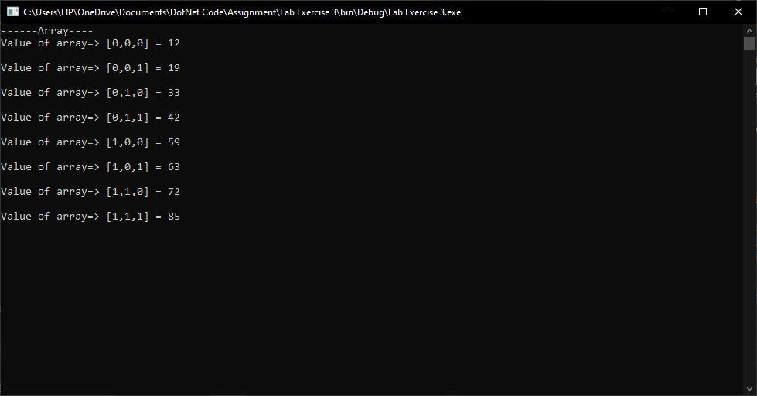

**Q7: Write a program in C# to create Dynamic Jagged array, store elements in an array and print it.**

**Solution:**

